
Lightwave Rural Hub - Bungay & Beyond

Vision Document July 2023
To watch our vision film go to: https://youtu.be/5aTlcSQbLSo
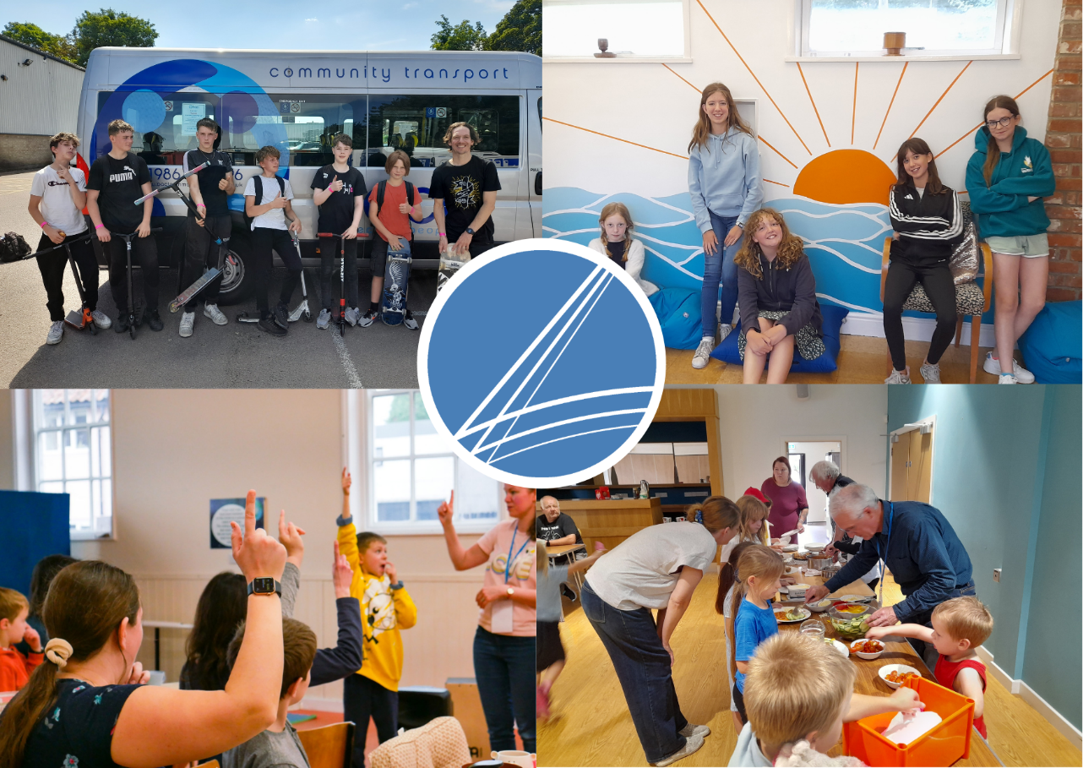

THE VISION

Is to form a Lightwave Rural Hub that brings LIGHT, LIFE & HOPE to children and young people in the Waveney and Blyth area.
LIGHT – We want children and young people to hear about and become disciples of Jesus - ‘The Light of the world’.
LIFE – We want to help children and young people navigate the challenges that Generation Z and A are facing so that they can experience ‘Life in all its fulness’.
HOPE – We want to equip 21st century disciples that can be carriers of Hope to the world.
The Lightwave Rural Hub:

- has a strong focus on prayer for God’s transforming work in the whole of the rural area for children and young people.
- develops a distinctive approach to connect with children and young people (e.g skateboarding, art, café and music).
- includes a new worshiping community that forms part of the mixed ecology of church in the Waveney and Blyth Deanery.
- develops community outreach and partnerships in the wider rural area including schools.
- works closely with other churches in the Waveney and Blyth area, providing resource and mission accompaniment for work with children and young people.

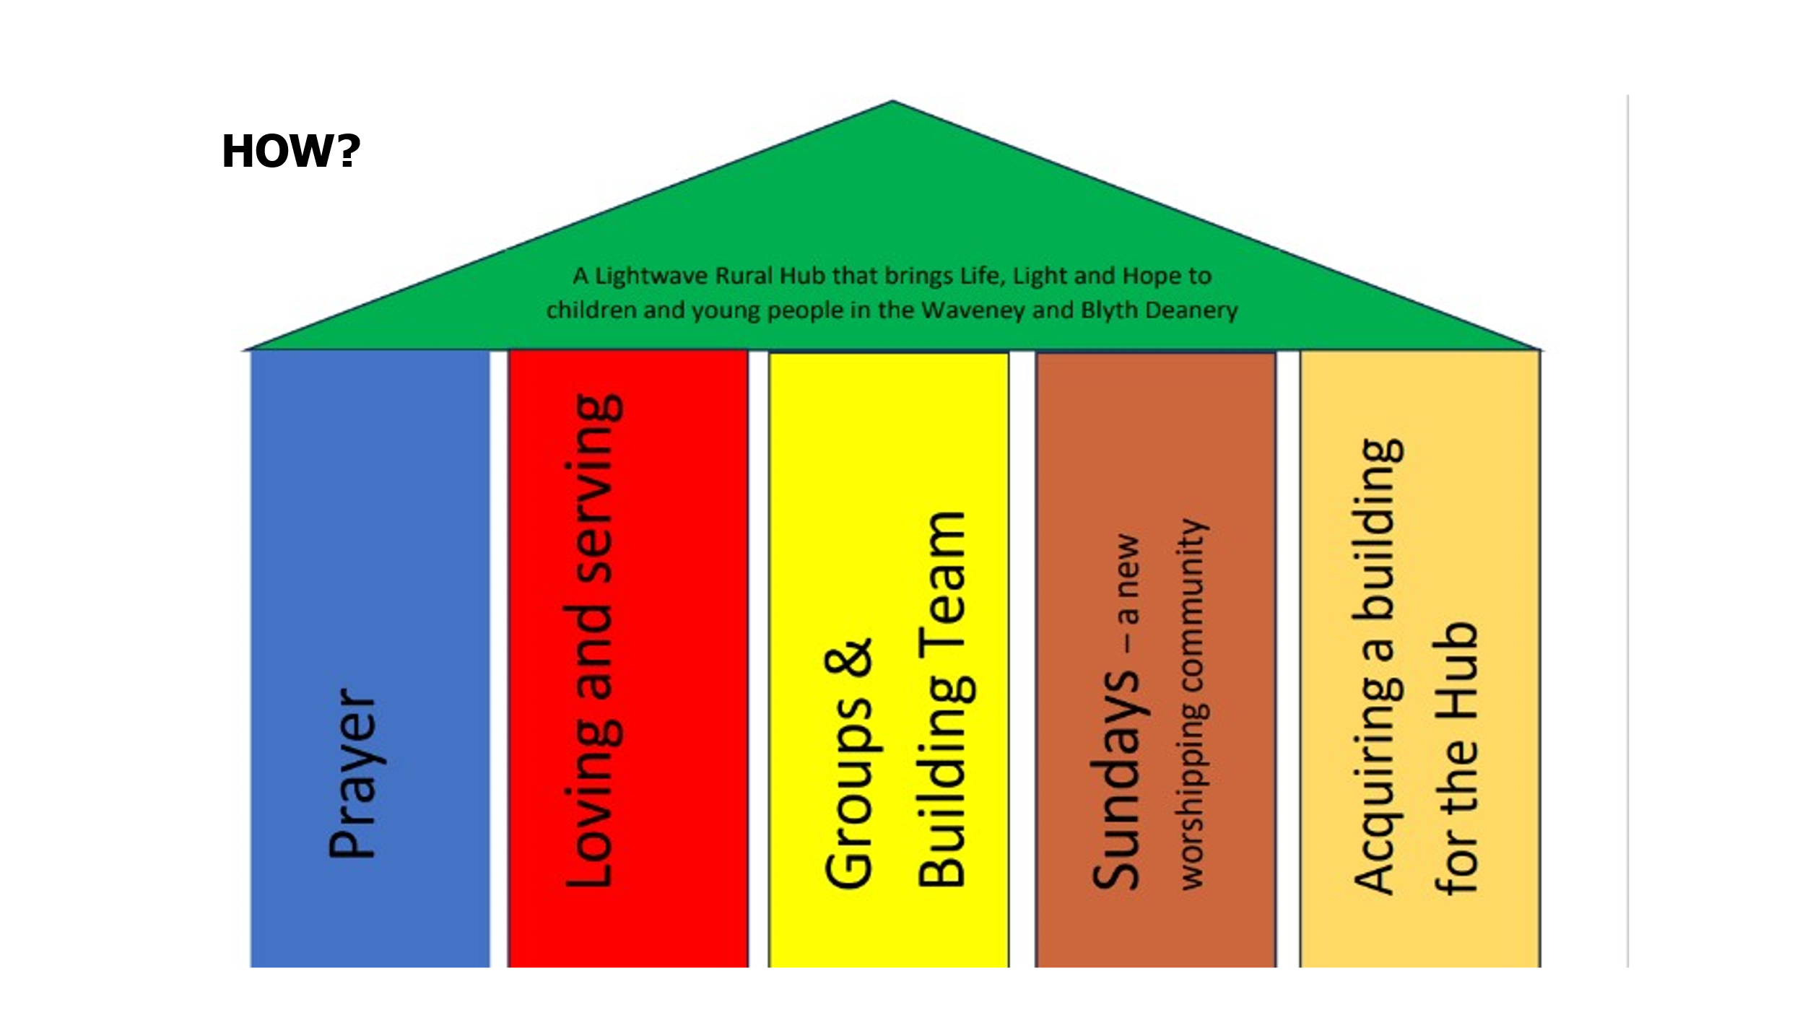
PRAYER - We are passionate about praying for children, young people and schools in the area.
LOVING & SERVING – We want to be ‘Good News’ in our community. The aim is to love and serve in practical ways.
GROUPS – Lightwave mid-week groups are a great place to be encouraged and to grow as a follower of Jesus.
BUILDING TEAM – We want to build a team that uses our different gifts and sets the culture for the vision.
SUNDAYS - A multigenerational new worshiping community. A weekly church service that is open to anyone and brings together the Lightwave groups.
THE VISION…
OUR OWN HUB BUILDING
- a welcoming, relevant & unique worship space for children and young people
- a multi-use space to include small groups, café area, skate ramp, music facilities, meeting rooms, office and storage
- a home for our new multigenerational worshipping community
To find out what we have been up to over the past year go to:
https://youtu.be/bLQnBkVBSTQ

Rev Edward Land, Leader of the Lightwave Rural Hub, Bungay, 07400033746 edward.land@lightwave.community

Heather Land Lay Pioneer Minister of the Lightwave Rural Hub, Bungay heather.land@cofesuffolk.org

